Info411 Convolutional Neural Network Code Architecture

To implement the CNN, the official dataset was used. The dataset contains 10,200 images in a single folder. CSV files denote the image IDs specified with their corresponding Model, Family, Manufacturer and Bounding Boxes.

Data processing

Raw data

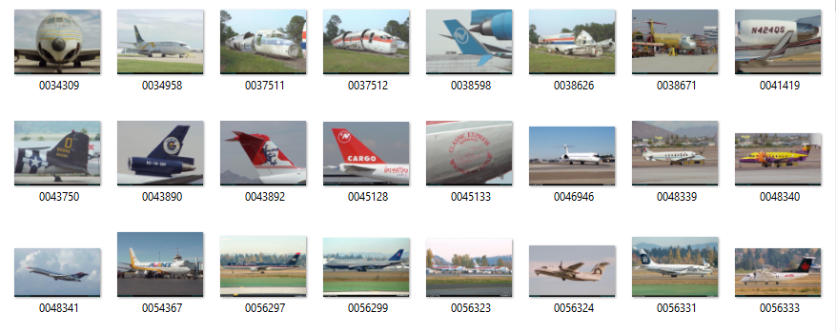

Reading data

ImageBoxFamilyLabeled

